|  |
| --- |
| Bond & Pollard Ltd |
| Sales Order Import User Guide |
| Demo Application |

|  |
| --- |
| Ian Bond  [Date] |

Contents

CSV file import process 2

Fixing rejected files 2

Importing an Order CSV File 3

Receiving CSV Files 3

Running The Import Program 4

Application Log 5

Import Errors Report 6

Fixing Errors 7

Orders Report 9

# CSV file import process

1. Sales order data is received in CSV format text files.
2. The files are named with the prefix ‘order’, and extension ‘.csv’.
3. Each file must have a unique name.
4. The process must be automated to run every hour, and import all new order CSV files received.
5. The data must be validated, and if there are any errors, the entire CSV file must be rejected, moved to an ‘Error’ directory, and all errors reported.
6. A manual procedure is required to fix rejected files.
7. If the data passes validation, load the data into the order tables.
8. Move successfully imported files to a ‘Processed’ archive directory.
9. Delete old error messages relating to the orders that have been successfully imported.

## Fixing rejected files

1. Manual intervention is required.
2. An import error report will show the following information for each rejected file:
   1. Filename.
   2. A key value that uniquely identifies the order: Order Reference.
   3. CSV data record (all fields).
   4. An error message identifying the invalid data.
   5. Date and time error reported.
3. Locate the rejected CSV file in the Error directory, via the filename on the error report.
4. Edit the CSV file, and manually correct each error reported.
   1. Order Reference may be altered, but you must check that there are no existing orders with the same reference.
   2. Dates must be in the format DD/MM/YYYY.
   3. Ship Date must be on or later than the Order Date, in the format DD/MM/YYYY.
   4. Customer ID invalid: contact the sales department to either obtain the correct code, or have a new account created.
   5. Product ID invalid: contact the sales department for the correct code.
5. Move the corrected file to the ‘Received’ directory to be re-processed.

# Importing an Order CSV File

In this demonstration we will:

1. Attempt to import order data from a CSV file which contains several errors.
2. Run a report to find out what the errors were.
3. Fix the errors in the CSV file.
4. Run the import process again with the corrected CSV file.
5. Run an order report to view the newly imported orders.

For this demonstration we will use the test order file ***order_data 017 ERRORS.csv*** which is the in the *data\pending* directory. Note that this file contains a number of errors, so the import will fail.

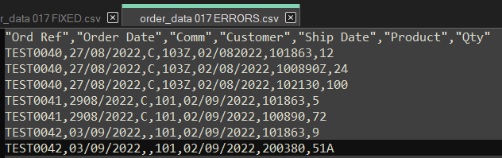

## Receiving CSV Files

Copy the CSV file from the data directory Pending to Received.

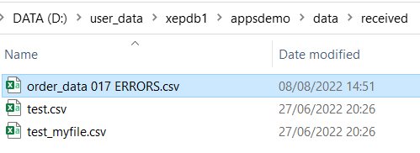

## Running The Import Program

Click on the APPSDEMO desktop shortcut.

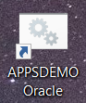

Run the *import_order* batch program. Enter the following commands at the prompt:

**XEPDB1\APPSDEMO>cd com**

**XEPDB1\APPSDEMO>import_order**

You will be prompted to enter the password for the connection user, *demo_connect.*

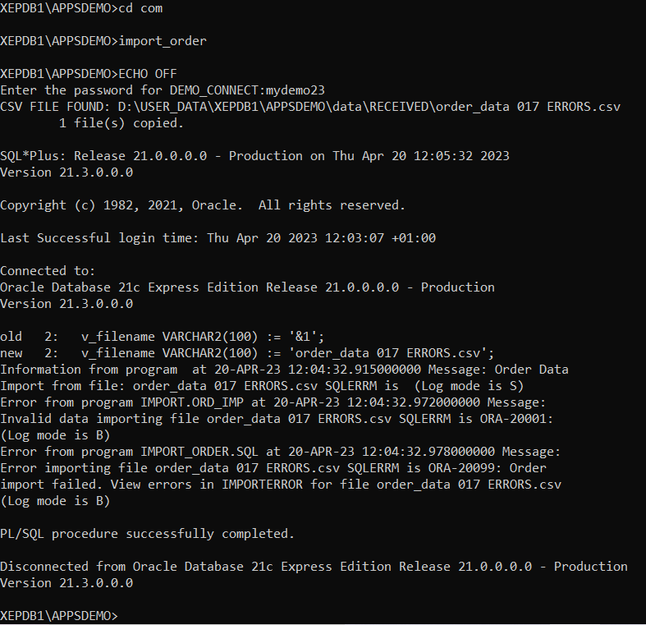

## Application Log

The program reported that there were errors importing the file *order_data 017 ERRORS.csv.*

To investigate further, open SQL Developer, connect to *demo_connect*, then open and run the SQL script ***applog.***

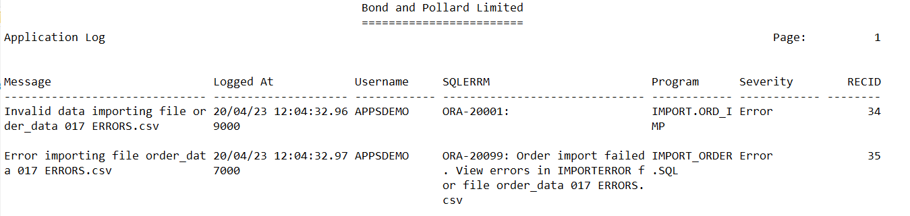

Note the error messages reported for the order file we tried to import.

## Import Errors Report

To view the detailed error messages, run the report ***import_errors.sql.***

Note that Key Value refers to the Order Reference field in the CSV file. The CSV data is shown against each error message so you can identify the row in the CSV file that needs to be fixed.

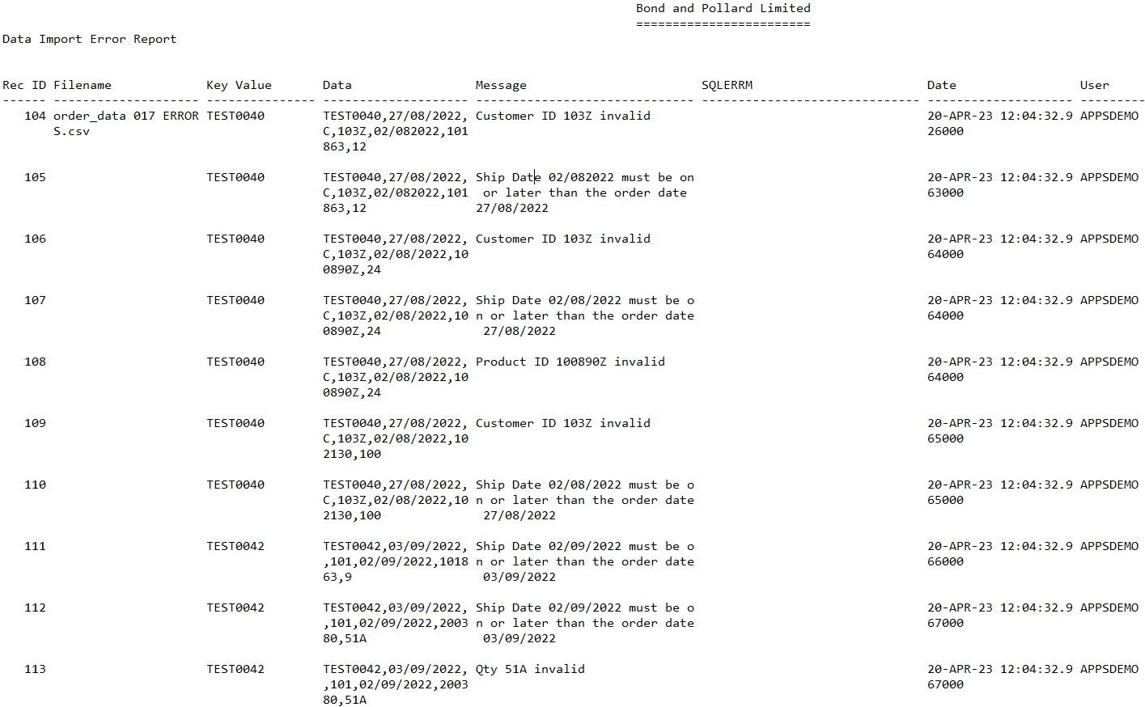

The following errors have been reported:

* TEST0040: Customer ID 103Z is invalid – the Z on the end should not be there, so the customer cannot be found.
* TEST0040: Ship Date 02/08/2022 is earlier than the order date. To correct this error, we need to change it to a date on or after the order date 27/08/2022.
* TEST0040: Product 100890Z invalid – the Z on the end should not be there, so the product cannot be found.
* TEST0042: Ship Date 02/09/2022 is earlier than the order date. To correct this error, we need to change it to a date on or after the order date 03/09/2022.
* TEST0042: Qty 51A invalid number. Just remove the A from the end.

## Fixing Errors

To fix the errors:

1. Find the CSV file in the error directory DATA_IN\error.
2. Edit the file and correct the above errors.
3. Move the file to the Received directory. For this demonstration, we will also rename the file to ***order_data 017 FIXED.csv***
4. Run the *import_order* program again, and check for errors.

Editing the file to correct the reported errors:

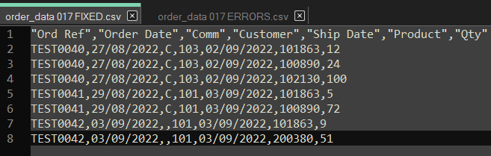

Run the *import_order* process again.

Enter the password for *demo_connect* when prompted.

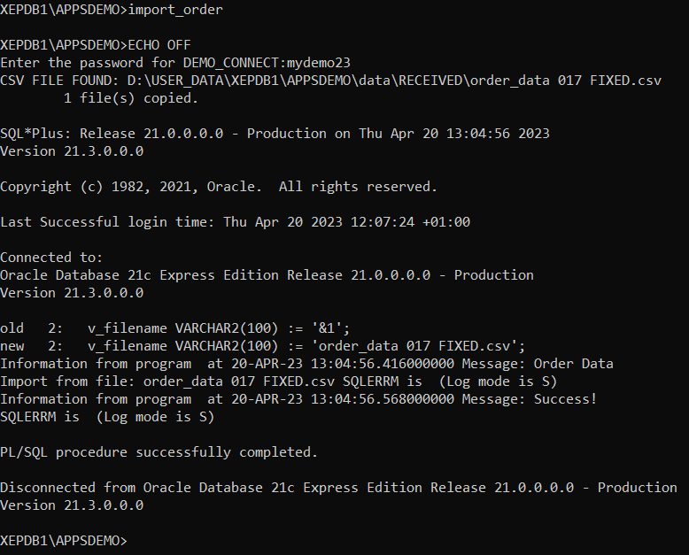

Note that this time we see the message **“Success!”.**

Run the *import_errors.sql* report again. This time, there should be no errors reported for the orders in the CSV file.

## Orders Report

Finally, run the orders report, ***orders_param.sql.*** Specify the range of orders to report as TEST0040 to TEST0042:

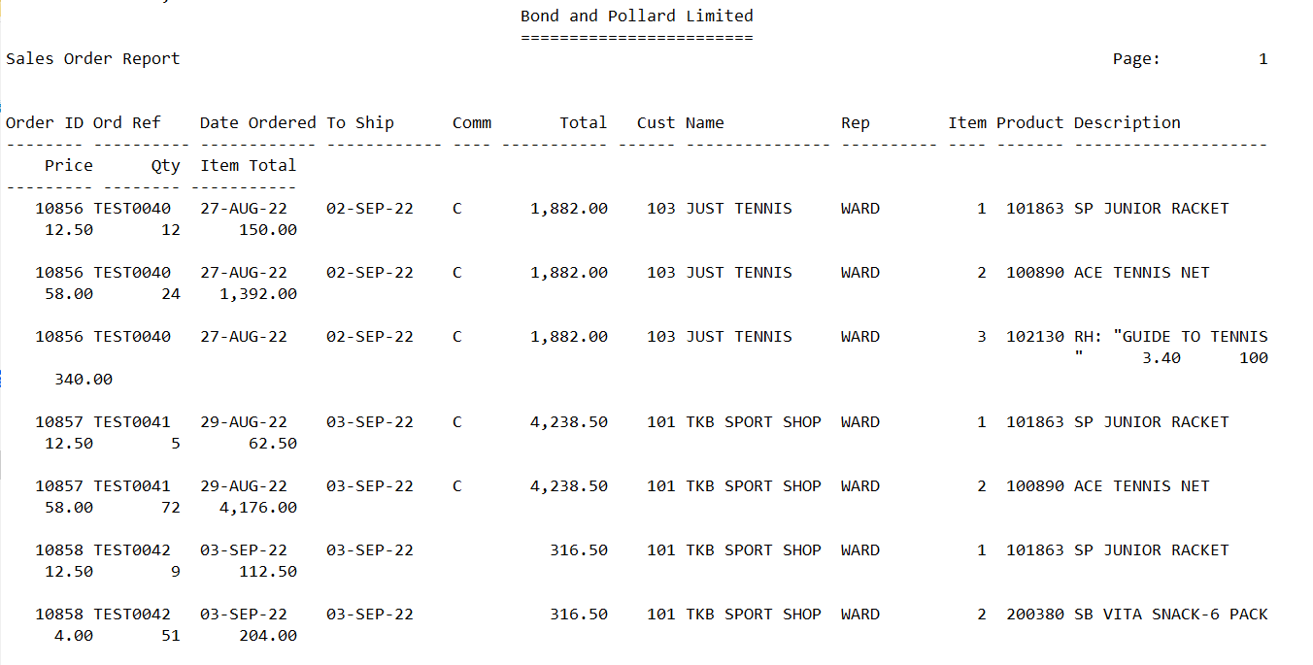

The orders in the CSV file have now been successfully loaded into the database.